**9-19-23 notes**

Control Flow with VBA

Goals

By the end of this lesson, you will be able to:

* Describe the basic syntax of a VBA for loop.
* Direct logic flow by using for loops and conditionals.
* List the benefits of using nested for loops.
* Explain the basic process of using nested for loops.
* Comprehend fundamental coding skills, including syntax recollection, pattern recognition, problem decomposition, and debugging.

**Budget Tracker**

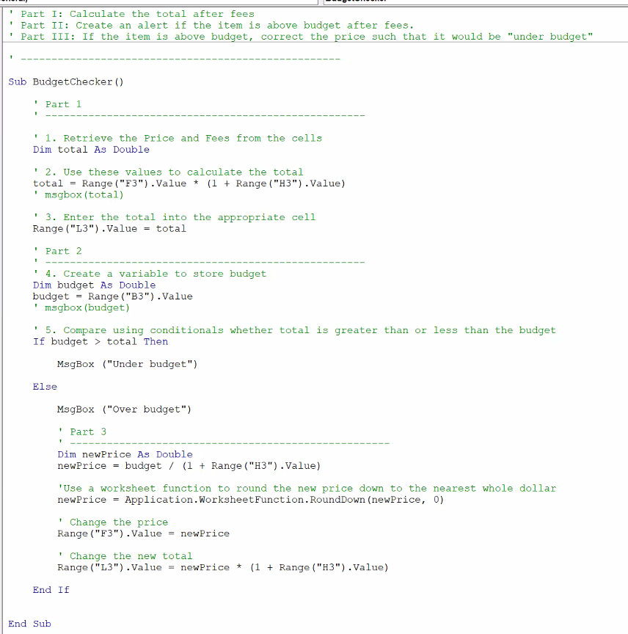

Loops:

I stands for iterator

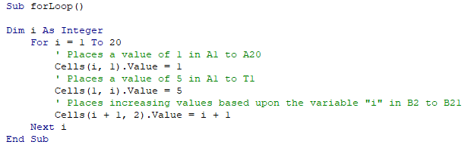

^Take care when reading Cells(). One of those is the letter I, the other is the number 1

**Chicken nuggets example:**

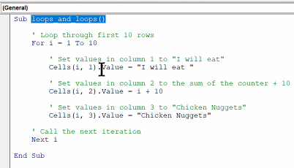

Mine:

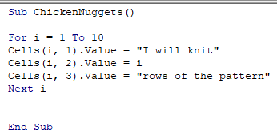

Reasons to use For rather than Range:

You can define the number of loops at the beginning instead of having to type out the range

You can have an increase coded in to the middle (column 2/B above)

**Mods**

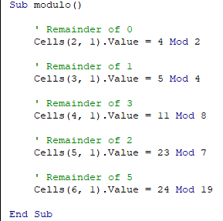

Mods are figuring out if there’s a remainder when you’re dividing.

Example: 5 divided by 2 yields 2 remainder 1

**Conditional Loops**

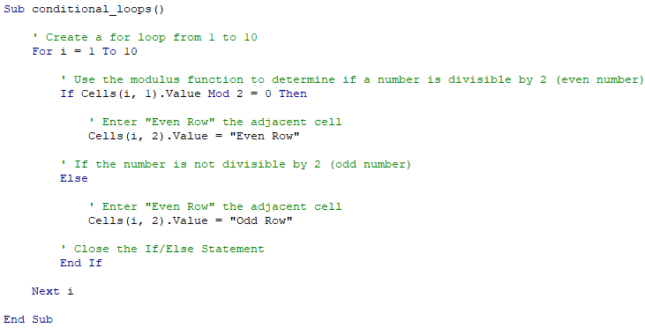

Example above uses mod to determine if the row is even, then types the phrase Even Row.

If the remainder after dividing by 2 is 0 then it’s even, else it types the phrase Odd Row

**FizzBuzz**

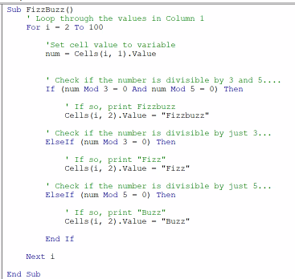

Order is important. If you put the calculation for Fizz as the first check, it’ll never check for FizzBuzz

**Lotto Search**

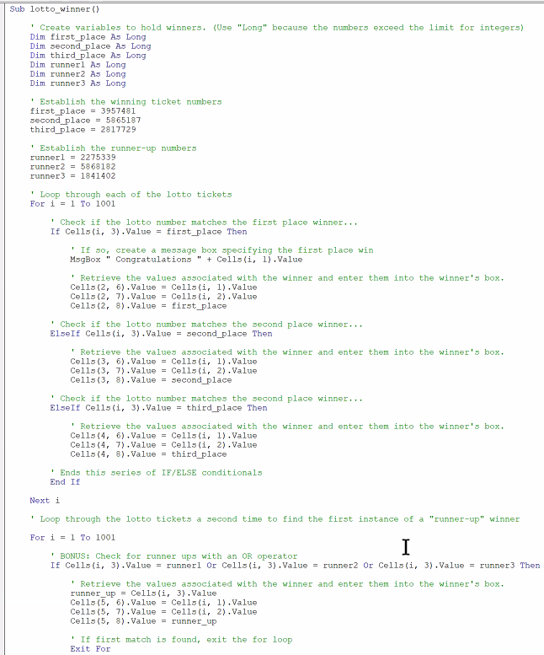

Code is followed by: End If, Next I, end sub

Breakdown of the LottoSearch code:

Variable declaration

Variable assignment

Loops

* Read the number, compare to 1st, 2nd, 3rd place variable
* If successful, type the text in the box to the right
* End if
* Move to next record (next i)
* Loop through again except looking for the runners-up

Else will only have a single action after it. It’s the last check. If you need multiple checks, use ElseIf. ElseIf can also be used as the last check, followed by EndIf

**Nested For Loops**

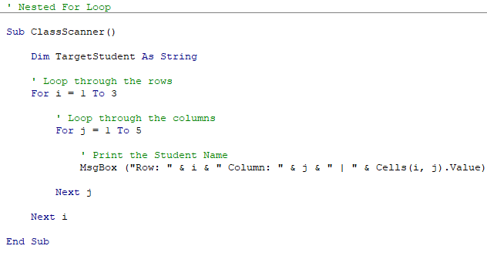

Nested loops make the computer remember where it is.

Example: I is 1, J is 1 equated to row 1, column 1. It spits out the value of the cell in the message box

Computer will complete inner loops before moving on in outer loops.

Questions: What does the & do in VBA? What does the vertical line between J and Cells(I,j).value

& concatenates the value (franken-smooshes it)

Apple & “ “ & Orange yields “Apple Orange”

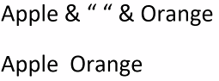

**Crypto Kennel:**

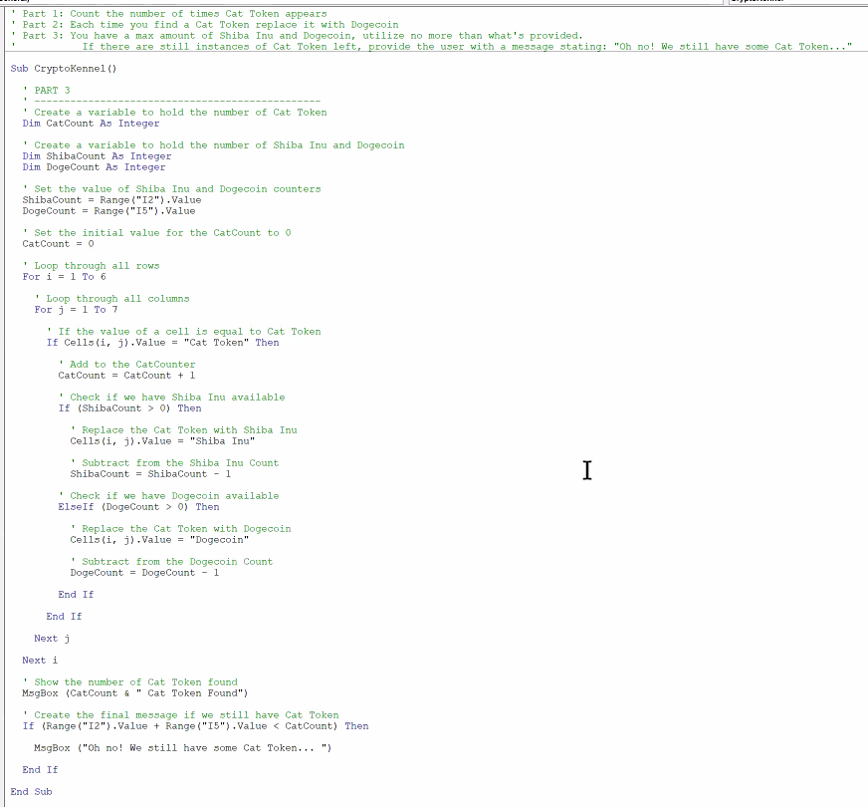

**Declaring variables:**

Dim____ as Long

Dim____ as Integer

Dim____ as Short

^different ways that data can be stored. Why use Long when you can use integer (Which holds smaller values than Short even)

Back in the day, the space that data took up was a much greater percentage of what was available than nowadays. Storing a value in the smallest type saved space and compiling time.

